

Bao Vu – e1800948

Phuc Le – e1800951

|  |
| --- |
| Huong Dang – e1800943 |
| Final Report Digital Systems Design |
| Measure temperature and transfer to digital signal |
|  |

|  |
| --- |
| Information Technology IT2018-3C- Vaasa University of Applied Sciences |

VAASAN AMMATTIKORKEAKOULU

UNIVERSITY OF APPLIED SCIENCES

Information Technology

**ABSTRACT**

Author Huong Dang, Bao Vu and Phuc Le

Title Final report of Digital Systems Design

Year 2020

Language English

Pages

Name of Supervisor Jani Ahvonen

This project is a small microcontroller-based system which will measure the environment temperature through LM35 sensor and then transfer it by transmitter and receiver, then convert the analog signal to digital signal. The final digital signal will be read by the Arduino Uno board.

After this project, our team has understood the mechanism of electronics components (analog and digital) and how we connect these components to the microcontroller.

We will test our signal design by breadboard, simulate it with LTSpice and then using PADS software to build the practical transmitter and receiver circuit.

**CONTENTS**

ABSTRACT

1 Analog signal processing 4

1.1 Task 1: Design 4

1.1.1 Calculation of resistance $R1$ 4

1.1.2 Calculation of $R3$: 5

1.1.3 Calculation of $R6$ and $R7$: 5

1.2 Task 2: Simulation 5

1.3 Circuit testing and verification in bread board 6

2 Communication 9

2.1 Task 1: Transmitter 9

2.2 Receiver 12

3 Analog to digital conversion 14

3.1 Task 1: Finish the analog to digital conversion and connect to the communication 14

3.2 Task 2 17

references 19

Analog signal processing

## Task 1: Design

In this task, one will design temperature sensor circuit, buffer circuit and differential amplifier circuit. The differential amplifier will be used to gain input voltage (-0.3V to 0.3V) to wanted level as in figure.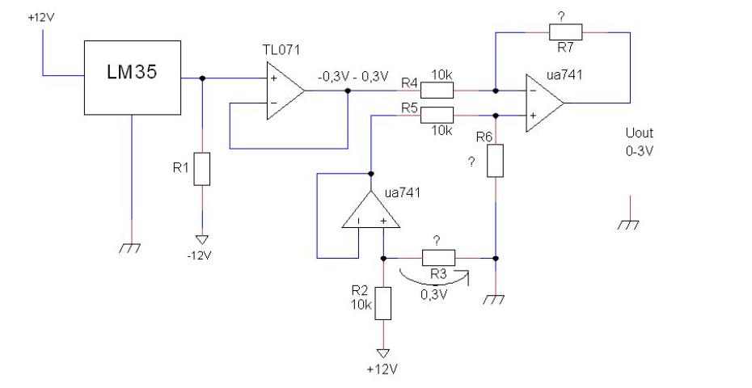

Figure 1. Task 1

The sensor LM35 output voltage will change -0.3V to +0.3V when environment temperature changes from -30 Celsius to +30 Celsius.

Now, we need to calculate the value of resistances:

### Calculation of resistance $R_{1}$

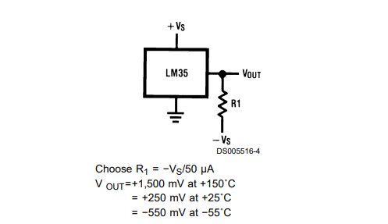

Figure 2. Full-range centigrade temperature sensor

From the datasheet of LM35, we have the equation of $R_{1}$ as following:

$$R_{1}=\frac{-V_{s}}{50μA}= \frac{12V}{50×{10}^{-6}A}=240000Ω=240kΩ$$

### Calculation of $R_{3}$:

We have:

$$I_{2}=\frac{12-0.3}{10000}=1.17×{10}^{-3}A$$

And because $I_{3}=I_{2}$, so that we can calculate $R_{3}$ as follow:

$$R_{3}= \frac{U_{3}}{I_{3}}= \frac{0.3V}{1.17×{10}^{-3}A}=256,41Ω$$

### Calculation of $R_{6}$ and $R_{7}$:

Because there is differential amplifier, so that:

$$R_{6}=R_{7}$$

and $U_{out}=\frac{-R_{7}}{R_{4}}×\left(U_{1a}-U_{1b}\right)$

Indeed, we have that when the range is from -300mV to 300mV, the output should become 3V to 0V. So, we have the equation of $R_{7}$ as follow:

$$R_{7}=R_{6}=U_{out}×\frac{-R_{4}}{(-0.3-0.3)}=3×\frac{-10000Ω}{-0.6}=50kΩ$$

## Task 2: Simulation

I use LTSpice to simulate the circuit with the following schematic and setup:

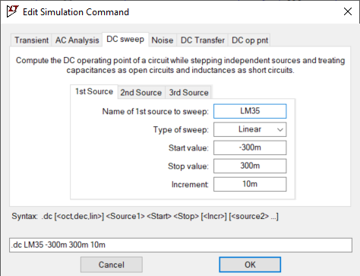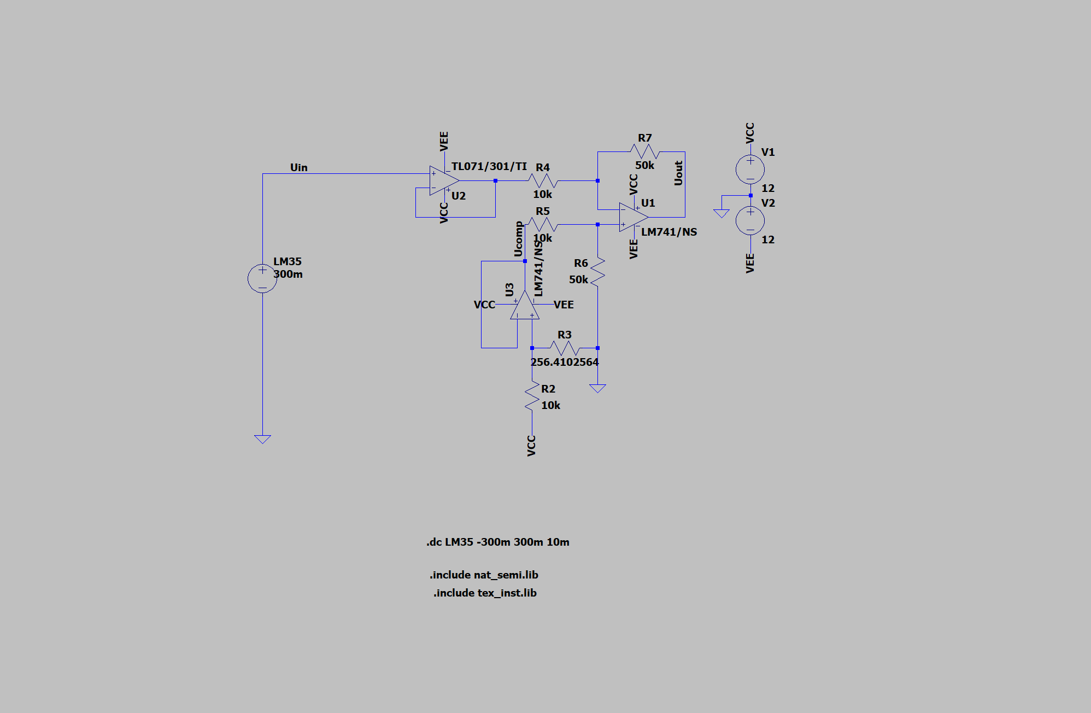

Figure 3. Setup and schematic

and as the final simulation result show for the $U_{in}$ and $U_{out}$:

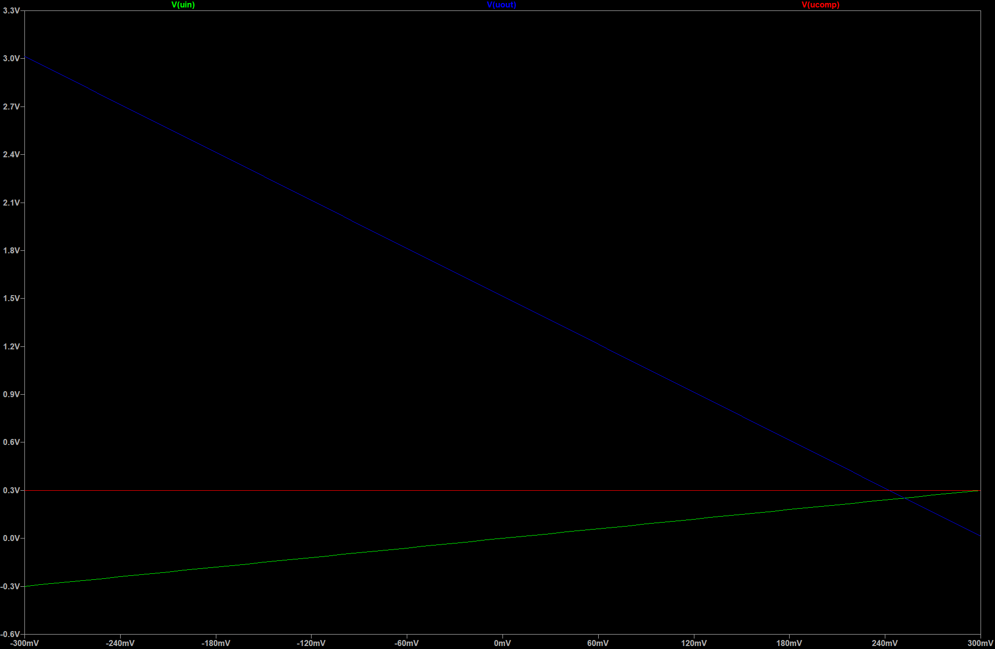

Figure 4. Simulation by LTSpice

LM35 temperature cannot be found from LTSpice libraries so it must be simulated by power supply. And I have set up the power supply as in figure 3: Using ${DC}_{sweep}$ with linear type of sweep which has start value at -300mV to 300mV and step is 10mV.

## Circuit testing and verification in bread board

We have tested our circuit in the bread board as following:

Figure 5. Analog signal processing circuit in bread board

We adjust the power supply (using instead of LM35) from -300mV to 300mV which has step is 50mV and fill in respectively output voltage in the following table:

Table 1. Changing of output voltage according to input voltage



For adjustment setting, to achieve accurate power supply, we use one multimeter to plug in the power supply and adjust the data. For zero adjustment, we plug the same positive cable and the ground cable to the ground (from the power supply). So that the lowest point of our differential amplifier output voltage is very close to value 0V.

On the other hand, to achieve the power supply from -300mV to 0mV, we change the place of power supply cable (using the red cable for positive and black one for ground): We were changing the red cable’s place and the black cable’s place.

Using a Fluke multimeter as showing in figure 5, we have one Fluke for measure the output voltage, one Fluke for measuring the input voltage (easier to adjust the input voltage).

And below is the paragraph which shows the output voltage according to the input voltage (using 50mV step):

Comparing the result from LTSpice simulation and the above paragraph, we can see that we achieve the same results from both charts. The bread board works quite good with adjustable DC-voltage supply: In real life practical, to save time, we are using step 50mV when record measurement instead of using step of 10mV as in DC sweep of ${LT}_{spice}$, thus, the data is not as much as in the ${LT}_{spice}$, but the charts show the same direction as well as values.

After connecting Adjustable DC-Voltage supply to the system input we connect LM35 sensor and using the spray to cool the sensor, but it was difficult to control the temperature for the LM35 input, so instead, we still used the DC-Adjustable voltage supply for other next tasks.

The PADs circuit diagram is attached in the next chapter (when we connect analog signal to the transmitter, then we draw in PADs logic the circuit).

# Communication

## Task 1: Transmitter

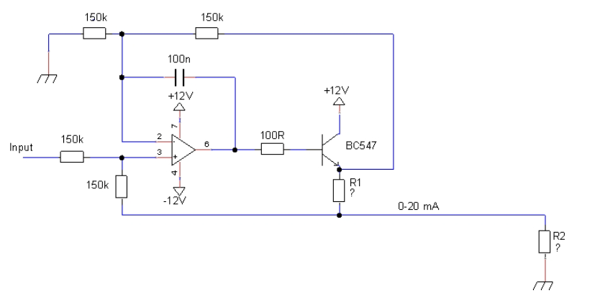

Figure 6. Transmitter schematic

In the previous task, we have created an analog signal which depends on environment temperature (record through LM35), and the output voltage of the previous circuit is changing from 3V to 0V when the temperature is changing from -30 Celsius to +30 Celsius, respectively. And in this task, we will calculate the resistors so that we can have 0-20mA current through $R_{1}$ when input voltage varies 0-3V DC.

Because when current 20mA flows in circuit the resistor $R_{2}$ must have 5V over it, so we have equation to calculate $R_{2}$ as follow:

$$R_{2}=\frac{5V}{20mA}=\frac{5V}{20×{10}^{-3}A}=250Ω$$

From the circuit schematic, the input voltage varies from 0-3V, as the same result, the voltage through the resistor R1 is also varies from 0-3V, we have the equation to calculate R1 following:

$$R_{1}=\frac{3V}{20mA}=150Ω$$

In the circuit, we are using 2 components: BC547 and uA741. BC547 is a NPN transistor hence the collector and emitter will be left open (reverse biased) when the base pin is held at ground and will be closed (forward biased) when signal is provided to base pin. uA741 is a single package Op-Amp that can be used for many general-purpose applications like: voltage follower, buffers, comparators, amplifiers,…

The reason why we are using the current as analog signal instead of using voltage is because we can transfer the signal more far away consider of there will be much less signal loss on the way transfer. Since the equation of resistor of the cable is $R=ρ\frac{l}{A}$, which $ρ$ is a constant number depends on material of cable, and l is the length of cable, A is the area of cross section. By calculation, it is easy to see that, by normal cable, we can transfer the signal in a very long cable without the fear of losing the signal.

Then, we simulate the circuit with LTSpice, as following figure:

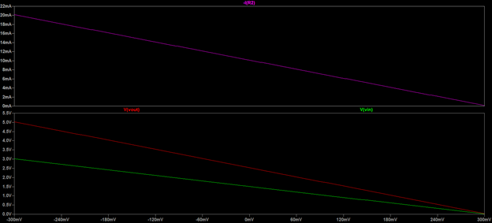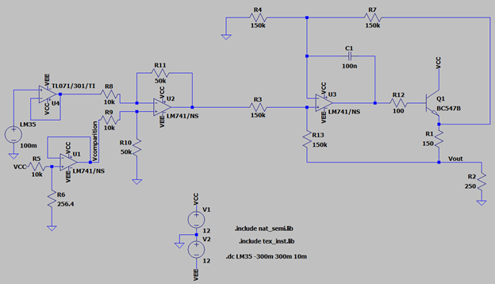

Figure 7. Transmitter

From the result of the simulation, we know that our calculation the resistors is correct, now we test our circuit with the breadboard in the figure 8. After built the circuit, we record the output current through a multimeter, and another multimeter is used to record the output voltage.

The record measurement will be listed in table 2, and with step 50mV as in table 1. In this case, we also make another paragraph to capture how the output signal current is changing due to the temperature sensor voltage output of LM35.

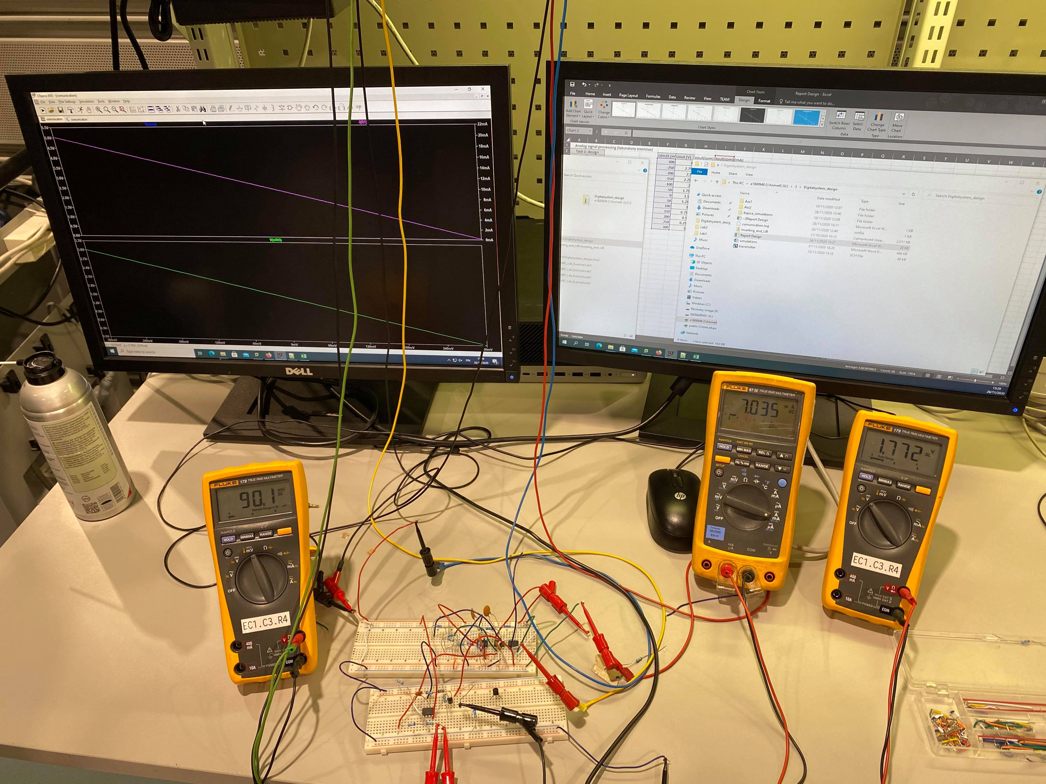

Figure 8. Transmitter in breadboard

And recorded measurement is as follow table:

Table 2. Output current of transmitter depends on LM35 output voltage



From the result, we have the following chart:

## Receiver

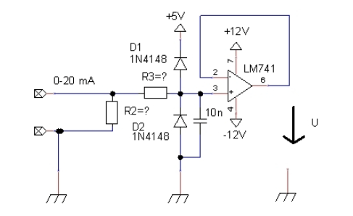

Figure 9. Receiver schematic

From previous transmitter circuit gives 0-20mA current and this current (signal) will be changed into voltage signal for analog to digital converter. To do this, we are using a receiver circuit (will making current to voltage transformations). The $R_{2}$ in figure 7 is also the same $R_{2}$ resistor in figure 6. In this receiver circuit, we will need to calculate the resistor of $R_{3}$. If there is an input signal which contains 8kV ESD discharge voltage, and we do not want to have the current through D1 or D2 during this ESD event is bigger than 0.8A, so the resistor ${ R}_{3}$ needed to be calculated as following:

$$R_{3}=\frac{U_{ESD}}{I_{ESD}}=\frac{8kV-12V}{0.8A}=10kΩ$$

From the circuit schematic, as you can see, we are using $R_{3}$ and a capacitor which is 10nF, this connection is making a low pass filter. This low pass filter will only allow low frequency signal from 0Hz to its cutoff frequency $f_{c}$. And the cutoff frequency is calculating as following equation:

$$f_{c}= \frac{1}{2πR_{3}C}=\frac{1}{2π×100kΩ×10nF}=159.155Hz$$

In the LTSpice, we draw the whole circuit so far by now as following:

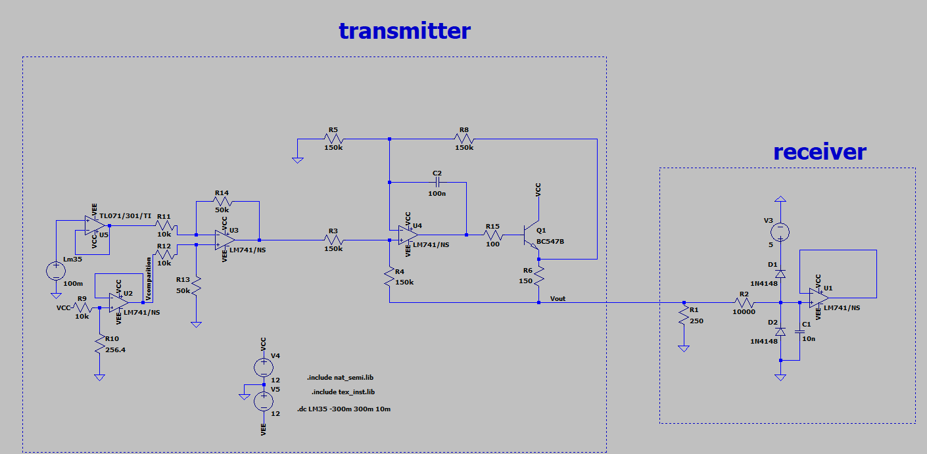

Figure 10. Communication circuit

Now, we have the next figure which is the simulation of the above figure about the receiver:

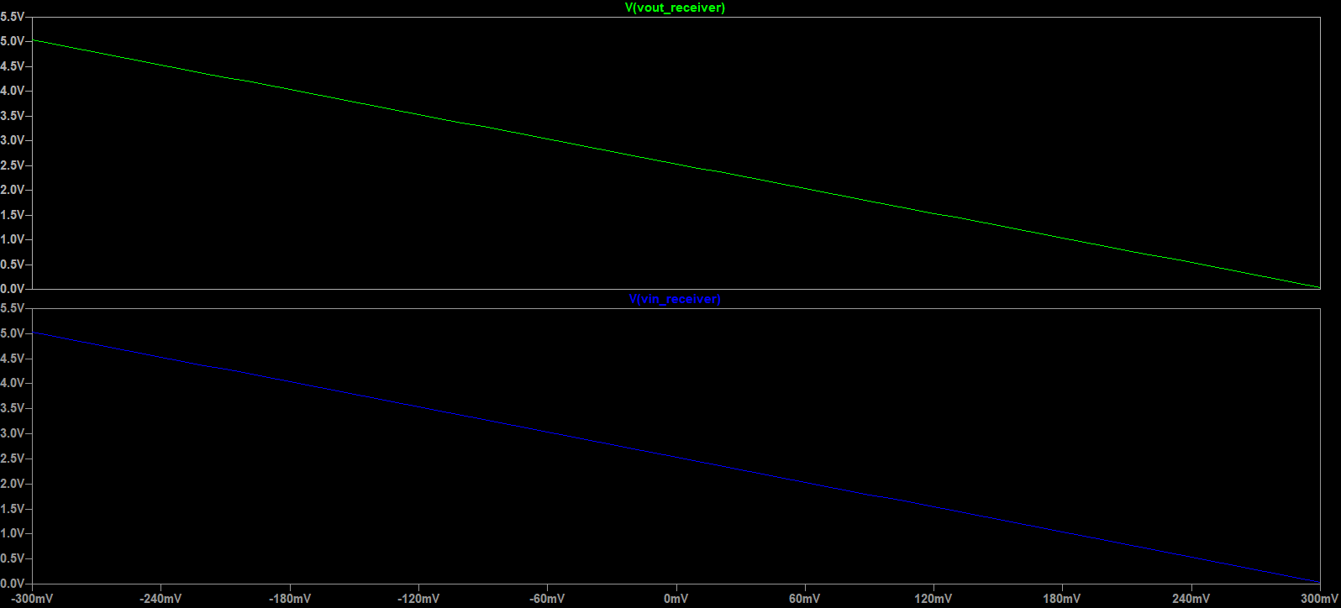

Figure 11. Receiver simulation

So, by the simulation result, our calculation so far is correct, now we are doing the receiver circuit in breadboard and test it to have the same result as in LTSpice. The circuit picture is in the figure 14. Then, as like testing the circuit in analog processing signal, we change the LM35 sensor to a supply power which can be adjust from -300mV to +300mV. Our team has tested, and the result of output voltage of the receiver is the same as the output voltage of the transmitter (the voltage that over resistor $R_{2}$)

# Analog to digital conversion

## Task 1: Finish the analog to digital conversion and connect to the communication

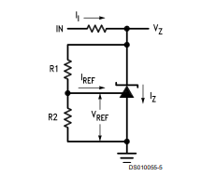In this task, we will connect our analog signal (varies from 0-5V) and convert it into digital signal by using MCP3002. In the datasheet of MCP3002, the Vdd (reference voltage) should be 5V as condition. To achieve that, we need a reference chip LM431.

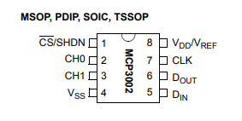

Figure 13. Circuit for Zener

Figure 12. Pin of the ADC

First step, we need to build a feeder circuit for the LM431 (as shown in figure 13). The output voltage through this adjustable Zener shunt regulator will be $V_{z}$ and is the reference voltage for out ADC. $V_{in}$ will be the same as input voltage +12V for amplifier we were using. Now, we will need to calculate the resistor R which has $I_{I}$ going through, and $R_{2}$ when we give the value of $R_{1}=10kΩ.$

To calculate R, we have the following equation:

$$R=\frac{V_{in}-V_{z}}{ I_{I}}=\frac{12V-5V}{10mA}=700Ω$$

Also, from the datasheet of LM431, we have $V_{ref}=2.5V$ and $I_{ref}=2μA$ (both typical values) and the equation as follow:

$$V_{z}=V_{ref}×\left(1+\frac{R_{1}}{R_{2} }\right)+I_{ref}×R_{1}$$

$$⇔5V=2.5V×\left(1+\frac{10kΩ}{R_{2} }\right)+2μA×10kΩ$$

$$⇔R_{2} =10kΩ$$

So, from the calculated value of R and $R_{2}$, we can build the analog to digital conversion circuit in bread board as follow:

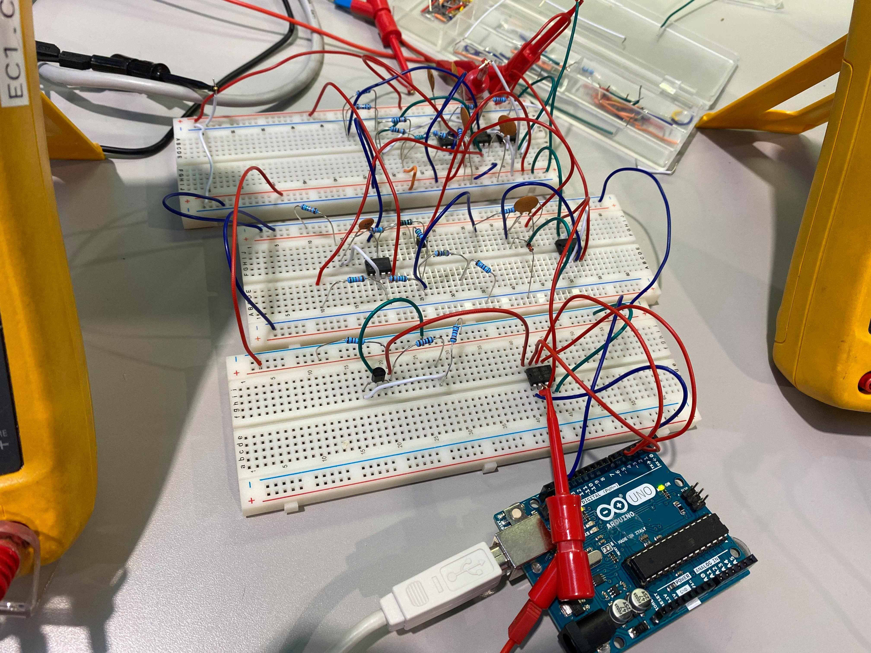

Figure 14. Final circuit in breadboard

After finishing the ADC circuit, now our signal is transferred into digital. Next step is connecting our digital signal to the UNO. Respectively, we connect CS pin, VSS (ground pin), $D_{out}$, $D_{in}$ and CLK pin from the MCP3002 with the pin of Arduino Uno board as is declared in the code:

#define CS_HIGH digitalWrite(2, HIGH)

#define CS_LOW digitalWrite(2, LOW)

#define CLK_HIGH digitalWrite(3, HIGH)

#define CLK_LOW digitalWrite(3, LOW)

#define DIN_HIGH digitalWrite(4, HIGH)

#define DIN_LOW digitalWrite(4, LOW)

#define DOUT digitalRead(5)

Pin number 3 of MCP3002 which is CH1, will take the analog signal from the receiver output signal. And the reference voltage (pin 8) will take from the output voltage of the LM431. (shown in figure 14)

In the next figure, it shows the signals between Arduino Uno board and ADC.

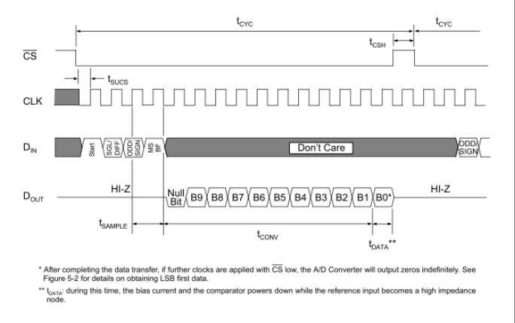

Figure 15. Communication with the MCP3002 using MSb first format only

After running the code in Arduino Uno, we have the serial motor as follow figure:

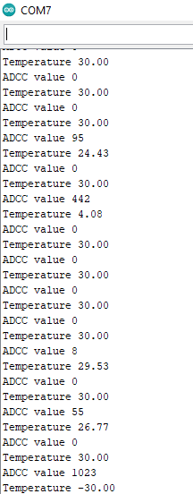

Figure 16. Temperature record in serial motor

## Task 2

Using the PADs Logic, we have drawn our transmitter circuit:

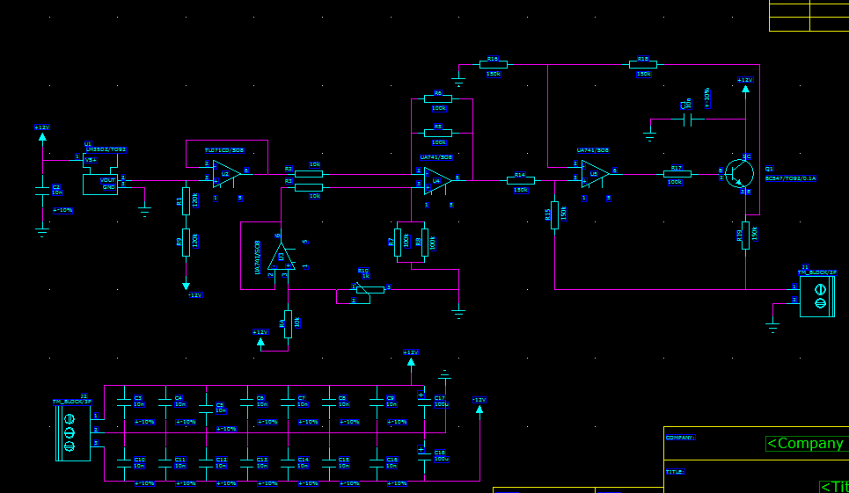

Figure 17. PADS circuit of transmitter

From this circuit, we had the PADS layout as follow:

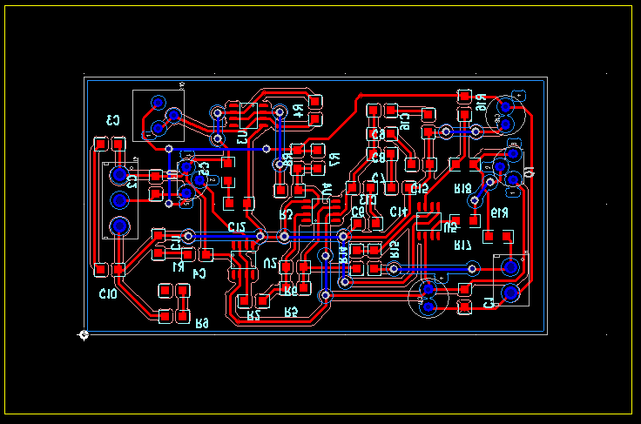

Figure 18. PADS layout

Here is our CAM preview for 2 layouts: bottom and top

Top components will contain through holes component.

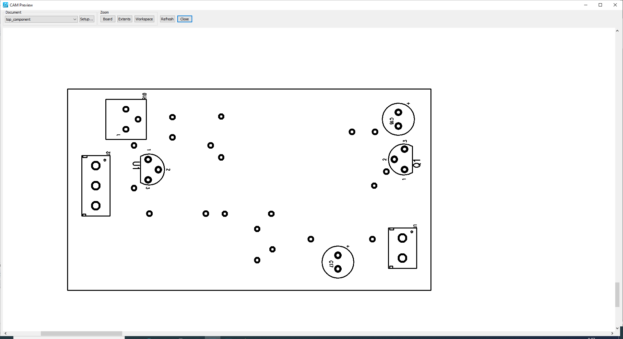

Figure 19. Top component review

On the other hand, bottom layout contains SMD components

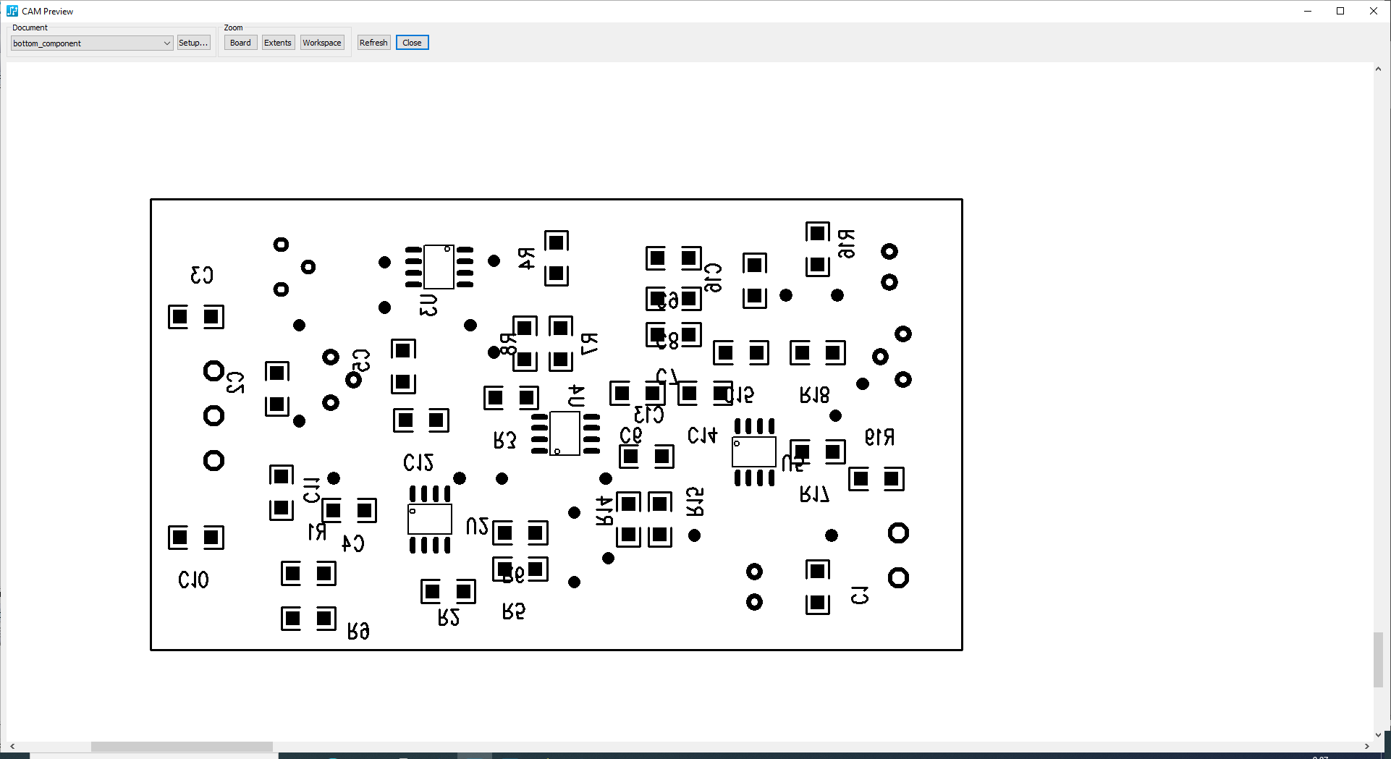

Figure 20. Bottom component

We have also the preview for top layout’s traces with via holes also:

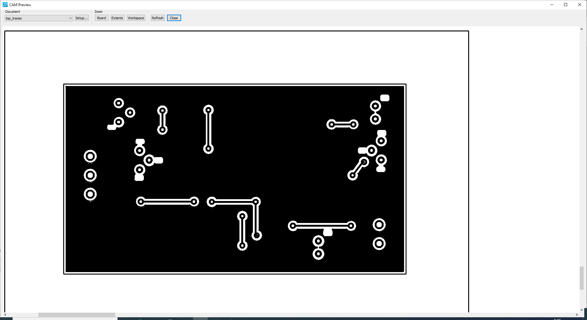

Figure 21. Top traces

And also the bottom traces, with also have the via holes, all throughole component traces must begin from the bottom side due to it is impossible for these component to solder:

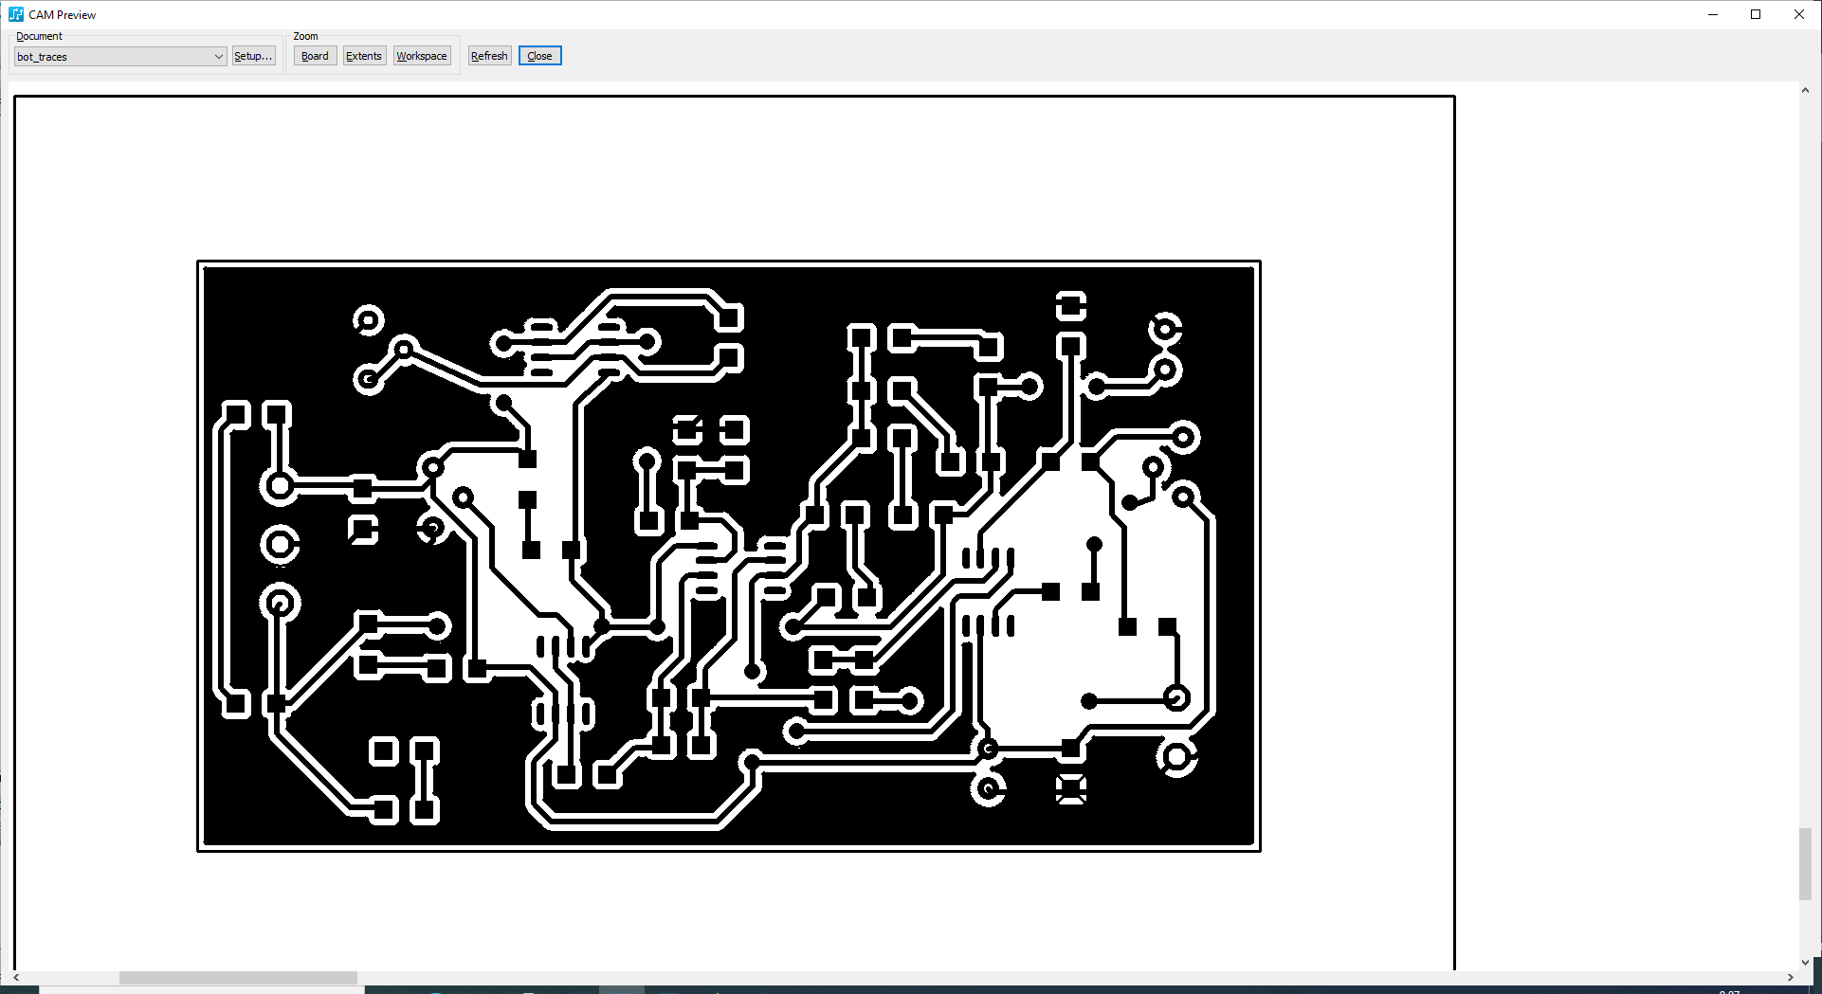

Figure 22. Bottom trace